**📘 Phase II – Logical Design & Implementation Plan**

**✅ Objective:**

Transform the business process and requirements (defined in Phase I) into a logical model using a well-structured **ERD** and prepare SQL table creation scripts that define the system's database structure.

**1. 🧩 Logical Data Model (ERD)**

**Entities & Attributes:**

**1. Member**

* member_id (PK) – NUMBER
* first_name – VARCHAR2(50)
* last_name – VARCHAR2(50)
* gender – VARCHAR2(10)
* dob – DATE
* email – VARCHAR2(100)
* phone – VARCHAR2(20)
* address – VARCHAR2(150)
* join_date – DATE
* status – VARCHAR2(20)

**2. Ministry**

* ministry_id (PK) – NUMBER
* ministry_name – VARCHAR2(100)
* description – VARCHAR2(200)

**3. Member_Ministry (Join Table)**

* member_id (FK) – NUMBER
* ministry_id (FK) – NUMBER
* join_date – DATE
* role_in_ministry – VARCHAR2(50)

**4. Event**

* event_id (PK) – NUMBER
* event_name – VARCHAR2(100)
* event_date – DATE
* location – VARCHAR2(100)
* description – VARCHAR2(200)

**5. Attendance**

* attendance_id (PK) – NUMBER
* event_id (FK) – NUMBER
* member_id (FK) – NUMBER
* status – VARCHAR2(20)

**6. Donation**

* donation_id (PK) – NUMBER
* member_id (FK) – NUMBER
* donation_date – DATE
* amount – NUMBER(10, 2)
* donation_type – VARCHAR2(30)

**7. Staff**

* staff_id (PK) – NUMBER
* full_name – VARCHAR2(100)
* position – VARCHAR2(50)
* salary – NUMBER(10, 2)
* hire_date – DATE

**2. 🗂️ Entity-Relationship Diagram (ERD)**

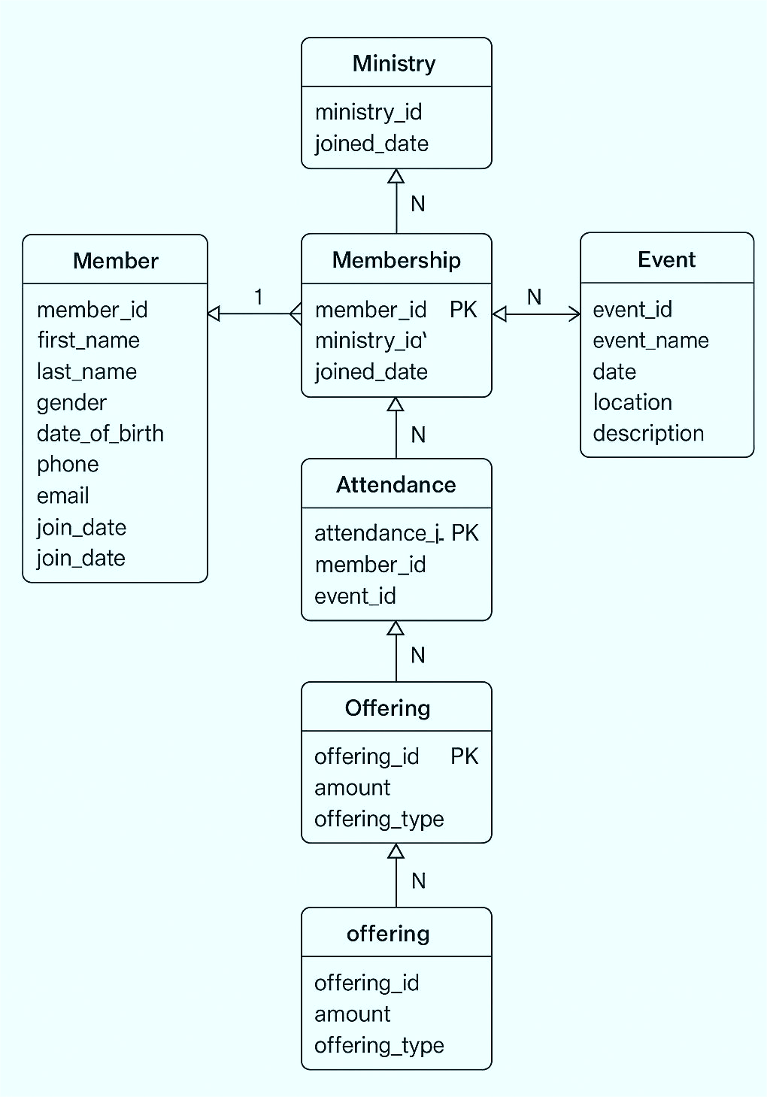

# 3. Relationships & Constraints

Established relationships:

Many-to-many: Member ↔ Ministry via Membership.

Many-to-many: Member ↔ Event via Attendance.

One-to-many: Member → Offering.

Applied constraints: NOT NULL, UNIQUE, CHECK, and DEFAULT to ensure data integrity.

# 4. Normalization

Ensured the model is in Third Normal Form (3NF):

Removed redundancy.

Ensured attributes depend only on primary keys.

No transitive dependencies.

# 5. Handling Real-World Scenarios

The model supports:

Multi-ministry memberships.

Event tracking and attendance.

Multiple offering types.

Extensible for future features like member roles or statuses.